KEYCHAIN ACCESS DISABLE / PASSWORD SYNC ISSUE /FINGERPRINT DISABLE ISSUE

What is secure token in mac IOS?

A secure token in macOS is a cryptographic key-wrapping attribute assigned to user accounts, essential for enabling FileVault disk encryption, authorizing software updates, and managing kernel extensions. It acts as a security chain of trust, ensuring only authorized users can unlock the encrypted APFS volume at startup.
Reason of disable and enable secure token:
Sometimes the Secure Token and the user’s login password become out of sync. This can happen when:
The user may experience:
- 🔒 FileVault unlock issues
- 🔑 Keychain password prompts repeatedly
- 🔄 Password not syncing between AD and macOS
- ❌ Login or authentication failures
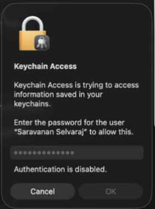

To avoid the above Please follow the below steps

Note: For user account lock post restart the Mac Office network not required, but for password update, user machine need to connect in the office network.
Step 1: Open terminal in user profile
Step 2: Login terminal as admin
step 3: Check for the secure Token is enable using the Following command.
sysadminctl -secureTokenStatus username
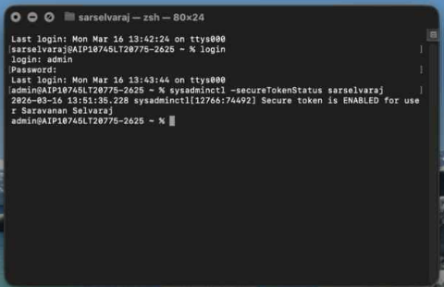

Step 4 : If the secure token is enable IT admin needs to disable it using the following, if its already in disable please move to the step 13
Step 5: sysadminctl -secureTokenOff Username -password - -adminUser admin -adminPassword –
Step 6: Once enter the command press enter, provide the admin password and user’s most recent password.
Step 7: Its show “DONE!” Now the secure token is disabled.

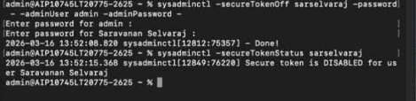

Step 8: Post disable the secure token as mentioned above we have to enable the secure token.
Step 9: sysadminctl -secureTokenOn <username> -password - -adminUser <adminusername> -adminPassword –
Step 10: Once enter the command press enter, provide the admin password and user’s most recent password.
Step 11: Its show “DONE!” Now the secure token is enabled.
Step 12: Logout from the admin terminal by “logout”
Step 13: Run the The command diskutil apfs updatePreboot / in macOS is used to update the Preboot volume information for the system disk in an Apple File System (APFS) container.

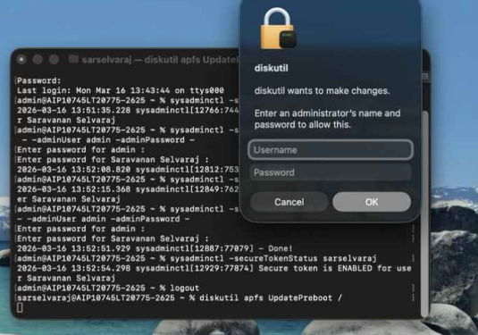
Step 14: Enter the admin credentials.
Step 15: Logout from user profile and login again in admin account.
Step 16: open for Keychain access for update the keychain password as user’s new
password.
Step 17: System – Look for active directory/Altimetrik, Double click.
Step 18: Click on show password and update the user’s new password there, click save changes.
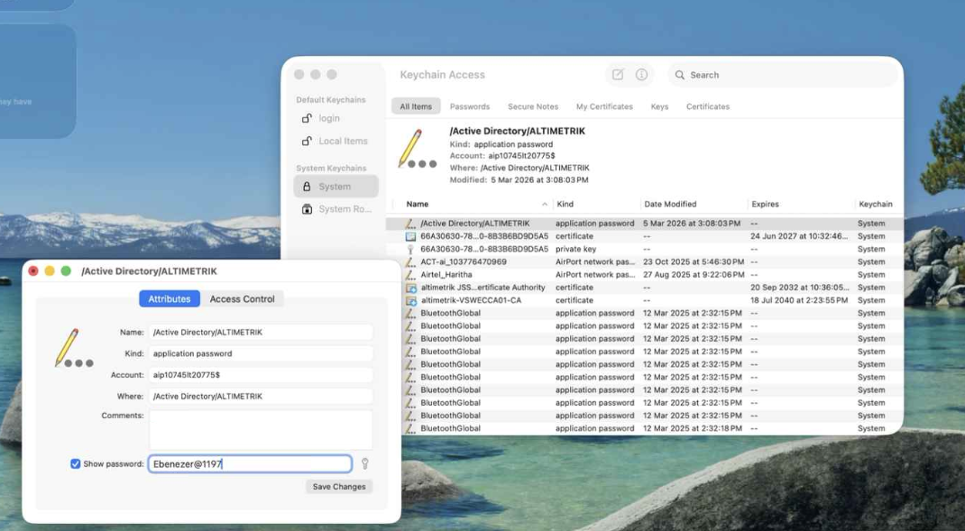

Step 19: Restart the Macbook and login with the new updated user password.
Step 20: Its prompt keychain, update password or create new password. Choose the update keychain. Enter the user’s password. Now the user machine login password and altimetrik SSO password synced. Also, the Authentication disable solved.

